LIST OF ASSUMPTIONS

* Assumptions for Company Dimension Table :-

Sample Data –

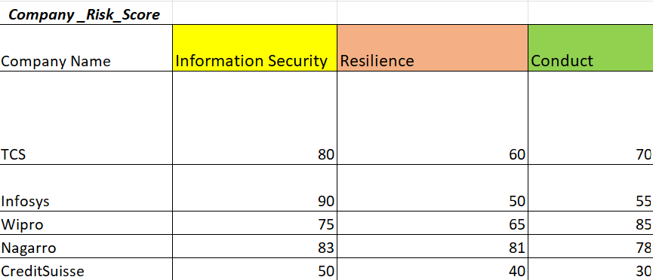

1. When an existing company with new dimension is added then a new column will be generated and the default value for other companies will be zero.

Example –

If company name is TCS in the input field, its dimension name is ‘XYZ’ and dimension value is 50 which is not present in the above sample. Then a new column ‘XYZ’ will be generated and its value for companies will be zero other than TCS.

1. When a new company is added with a new dimension then a new column will be generated and the default value for other companies will be zero. New company will also have existing dimension as its dimension, but the value of that dimensions will be zero.

Example –

If company name is Accenture in the input field, its dimension name is ‘XYZ’ and dimension value is 50 which is not present in the above sample. Then a new column ‘XYZ’ will be generated and its value for companies will be zero other than Accenture. Also, Accenture will have dimension value of information security, resilience and conduct as zero.